Retail Business Analytics Dashboard Document
1️⃣. Question: Top Categories by Total Price
Visualization: Stacked bar chart
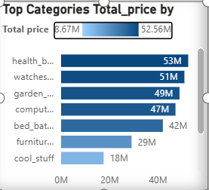
Explanation:
1.Visualization Used: Stacked Bar Chart
A stacked bar chart is chosen because:
- It allows easy comparison of total price across categories
- Select Stacked Bar Chart from the Visualizations pane
- Drag fields:
- Category → Y-axis
- Total Price → X-axis / Values
- (Optional) SubCategory → Legend

2. Data Requirements
To solve this problem, the dataset must contain at least:
- Category name
- Total Price
3. Create Total Price Measure:
Total price = sum(product_category_name_translation[price])
4. Show Top Categories (Optional – Top N Filter)
- Select the stacked bar chart
- Go to Filters pane
- Drag Category to Filters
- Change filter type to Top N
- Set:
- Show items: Top 5
- By value: Total Price
- Click Apply filter

5. Formatting & Enhancements
To improve clarity and presentation:
- Turn Data labels ON to show values
- Sort categories by Total Price (Descending)
- Apply consistent colors for better readability
- Add a clear Title: "Top Categories by Total Price"

2️⃣. Question: Delayed Order Analysis
Visualization: clustered bar chart
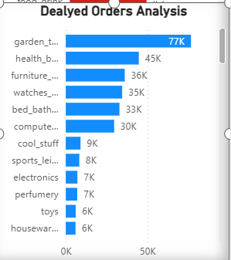
Explanation:
1.Data Understanding
To solve this problem, the dataset must contain at least the following columns:
- Order Date – Date when the order was placed
- Ship Date / Delivery Date – Date when the order was shipped or delivered
- Expected Delivery Date (or delivery SLA)
- Order ID – Unique identifier of each order
2. Create a Delayed Order Logic:
Delivery_status = if(product_category_name_translation[order_delivered_customer_date]>product_category_name_translation[order_estimate_delivery_date],"Dealyed","On time")
3. Create Measure for Order Count:
total_order = COUNT(product_category_name_translation[order_id])
Delayed order = CALCULATE([total_order],product_category_name_translation[Delivery_status]="Dealyed")

4. Formatting the Visual
To make the chart more readable:
- Use distinct colours for Delayed and On-Time orders
- Turn Data Labels ON
- Sort bars by Delayed Orders (Descending)
- Add a clear title: "Delayed Order Analysis"
5. Insights from the Visualization
Using the clustered bar chart, we can easily:
- Identify periods or categories with higher delays
- Compare delayed orders against on-time orders
- Detect operational bottlenecks

3️⃣.Question: Monthly Comparison of Delayed vs On-Time Orders
Visualization: card, slicer, stacked column chart
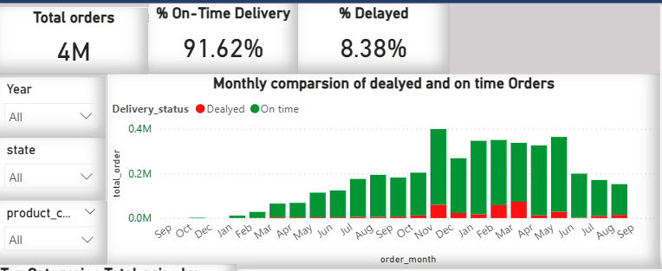
Explanation:
1. Objective of the Problem
The objective of this analysis is to compare delayed and on-time orders on a monthly basis and understand:
- Overall order volume
- Percentage of on-time deliveries
- Percentage of delayed deliveries
- Monthly delivery performance trends
2. Data Understanding
To solve this problem, the dataset should include the following columns:
- Order ID – Unique identifier for each order
- Order Date – Used to extract month and year
- Expected Delivery Date – Planned delivery date
- Actual Delivery Date / Ship Date – Actual delivery date
- Delivery Status (derived) – Delayed or On Time
Optional fields used for slicing:
- Year
- State
- Product Category
3. Create Delivery Status:
Delivery_status = if(product_category_name_translation[order_delivered_customer_date]>product_category_name_translation[order_estimate_delivery_date],"Dealyed","On time")
4. Create Required Measures:
- total_order = COUNT(product_category_name_translation[order_id])
- on_time_orders = CALCULATE([total_order],product_category_name_translation[Delivery_status]="On time")
- Delayed order = CALCULATE([total_order],product_category_name_translation[Delivery_status]="Dealyed")
- on-time =DIVIDE(CALCULATE(COUNT(product_category_name_translation[order_id]),product_category_name_translation[Delivery_status] = "On time" ) ,COUNT(product_category_name_translation[order_id]))

- Delyaed % = DIVIDE(CALCULATE( COUNT(product_category_name_translation[order_id]),product_category_name_translation[Delivery_status] = "Dealyed" ), COUNT(product_category_name_translation[order_id]))
5.Create Month Field
order_month = FORMAT(product_category_name_translation[order_date],"MMM")

6. Formatting & Design Choices
- Green color → On-Time Orders
- Red color → Delayed Orders
- Data labels enabled for clarity
- Clear title:"Monthly Comparison of Delayed vs On-Time Orders"

4️⃣.Question: Payment Method Analysis
Visualization: pie chart
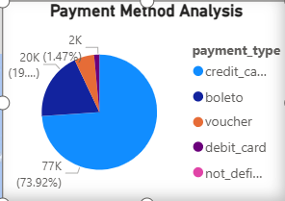
Explanation:
1. Objective
Identify most frequently used payment methods by customers using a clean and visually appealing visual.
2. Required Columns
Your table should contain:
- OrderID
- PaymentMethod (UPI, Credit Card, Cash, etc.)
3. Create Measure: Number of Orders
total_order = COUNT(product_category_name_translation[order_id])
4.Format for Better Look
Turn on Data Labels
- Select chart
- Format → Detail labels
- Turn ON
- Show → Percent of total
- Title Payment Method Analysis

5️⃣.Question: Product Rating Analysis
Visualization: stacked column chart
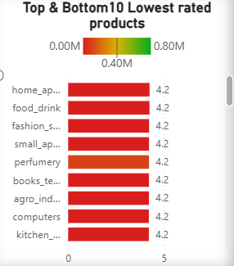
Explanation:
1. Objective of the Problem
The objective of this analysis is to evaluate product performance based on customer ratings and identify:
- Top-rated products
- Lowest-rated products
- Rating distribution across products
2.Data Understanding
To perform Product Rating Analysis, the dataset should contain:
- Product Name / Product Category – Identifies each product
- Rating – Customer rating
- Order ID / Review ID – For counting purposes
3.Rating Measures
avg_product_rating = AVERAGE(product_category_name_translation[Rating])
4. Identify Top & Bottom Rated Products
top bottom flag = if([Product rating rank]<=10||[Product rating rank]>=COUNTROWS(ALL(product_category_name_translation[product_name]))-9,1,0)
5. Filter Logic (Top & Bottom Products)
Apply Filter (Important)
- Select the chart
- Filters pane → Filters on this visual
- Drag Top Bottom Flag
- Set filter to is 1
Now only Top 10 + Bottom 10 products appear
6. Formatting & Design
- Use conditional colors to highlight:
  - Green → Higher ratings
  - Red → Lower ratings
- Enable data labels to show rating values
- Rotate axis labels for better readability
- Add title:"Top & Bottom Rated Products"

6️⃣.Question: State-wise Sales Analysis
Visualization: Map
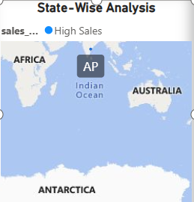
Explanation:
1. Objective
Identify states with high and low sales and present regional sales performance visually.
2. Required Columns
Your dataset should have:
- State
- SalesAmount (or Price)
- OrderID
3. Create Total Sales Measure
Total price = sum(product_category_name_translation[price])
4. Formatting (Important)
- Format → Data colors
- Use Gradient
- High sales → Dark color
- Low sales → Light color
- Title State-wise Sales Performance
5. Turn ON Tooltips
Tooltip fields:
- State
- Total Sales
- Total Orders (optional)

7️⃣.Question: Seasonal Sales Patterns
Visualization: Line Chart
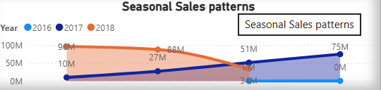
Explanation:
1.Objective
Investigate quarter-wise seasonal patterns and sales trends over the year to identify peak and low seasons.
2. Required Columns
Your dataset should have:
- OrderDate (or Sales Date)
- SalesAmount / Revenue
Optional fields used for slicing:
- Year
- State
- Product Category

3. Create Date Intelligence Columns
Quarter = "Q" & FORMAT(product_category_name_translation[order_date],"Q")
Year = YEAR(product_category_name_translation[order_date])
- Create Total Sales Measure:
Total price = sum(product_category_name_translation[price])
avg state sales =AVERAGEX(VALUES(product_category_name_translation[state]),[Total price])

8️⃣.Question: Revenue Analysis
Visualization: line and clustered column chart
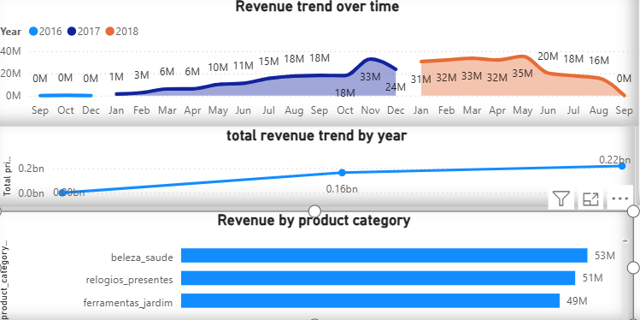
Explanation:
TOTAL REVENUE TREND BY YEAR – STEP BY STEP
1: Create Required Columns & Measure
1. Year Column
If you don’t already have a Year column:
- Go to Data view
- Create a new column:
Year = YEAR(Sales[Order Date])

2. Total Revenue Measure
- Go to Modeling → New measure
Total Revenue = SUM(Sales[Revenue])
Format:
- Data type: Currency
- Symbol: ₹ /
3: Add Fields to the Line Chart
Fields Placement
Area | Field
X-Axis | Year
Y-Axis | Total Revenue

4: Sort Year Correctly
- Click the three dots (⋯) on the chart
- Select Sort by Year → Ascending

5: Format the Chart
A) Line Style
- Open Format visual
- Go to Lines
  - Color: Blue / Green
  - Width: 2–3
  - Markers: ON

B) Data Labels
- Go to Data labels
- Turn ON
- Display units: None
- Position: Above

C) X-Axis
- Expand X-Axis
- Title: ON → “Year”
- Gridlines: OFF

D) Y-Axis
- Expand Y-Axis
- Title: ON → “Total Revenue”
- Display units: Millions
- Gridlines: ON (light)
🎨 E) Background & Border
- General → Effects
- Background → ON (White)
- Border → ON
- Rounded corners → 10–15

REVENUE BY PRODUCT CATEGORY – STEP BY STEP
1: Check Required Fields
Make sure your dataset has:
- Product Category
- Revenue (or Quantity × Price)
2: Create Total Revenue Measure
If not already created:
- Go to Modeling → New measure
Total Revenue = SUM(Sales[Revenue])
Format → Currency (₹ / $)

3: Add Fields to the Chart
Field Area | Field
Y-Axis | Product Category
X-Axis (Values) | Total Revenue
✔️ This will automatically show revenue for each category
4: Sort Categories by Revenue
- Click three dots (⋯) on the chart
- Select Sort by → Total Revenue
- Choose Descending
📈 Top-performing category appears first
5: Format the Chart (Important)
A) Bars
- Open Format visual
- Go to Bars
  - Color: Blue / Green
  - Inner padding: 15–20%
B) Data Labels
- Go to Data labels
- Turn ON
- Display units: Millions
- Position: Outside end
C) X-Axis (Revenue Axis)
- Go to X-Axis
- Title: ON → “Total Revenue”
- Display units: Millions
- Gridlines: ON (light)
D) Y-Axis (Category Axis)
- Go to Y-Axis
- Title: ON → “Product Category”
- Gridlines: OFF
E) Background & Border
- General → Effects
- Background: ON (White)
- Border: ON
- Rounded corners: 10–15

